| **Feature/Aspect** | **Apache Spark** | **MapReduce** | **Apache Hive** | **Apache Pig** |
| --- | --- | --- | --- | --- |
| **Speed** | Very fast (in-memory processing) | Slower (disk I/O operations) | Slower (depends on MapReduce, can use Tez/LLAP) | Comparable to MapReduce (disk I/O operations) |
| **Ease of Use** | High-level APIs (Java, Scala, Python, R), interactive shell | Requires writing low-level code (Java) | SQL-like HiveQL | High-level scripting language (Pig Latin) |
| **Processing Model** | Directed Acyclic Graph (DAG) | Map and Reduce functions | Translates HiveQL into MapReduce jobs | Translates Pig Latin scripts into MapReduce jobs |
| **General-purpose** | Yes (batch, interactive queries, real-time streaming, ML, graph processing) | No (primarily batch processing) | No (primarily data warehousing) | No (primarily batch processing and ETL) |
| **Libraries** | Built-in libraries (MLlib, GraphX, Spark Streaming) | No built-in libraries | Allows user-defined functions (UDFs) | Allows user-defined functions (UDFs) |
| **Performance** | Up to 100x faster in memory, 10x faster on disk | Slower due to frequent disk I/O | Generally slower, newer versions improved | Performance comparable to MapReduce |
| **Extensibility** | Highly extensible with built-in and third-party libraries | Extensible but complex | Extensible with UDFs in Java | Extensible with UDFs in multiple languages |
| **Real-time Processing** | Yes (Spark Streaming) | No | No | No |

**Use Cases for Apache Spark**

1. **Batch Processing**:
   * **ETL (Extract, Transform, Load)**: Spark can process large volumes of data from various sources, transform it, and load it into data warehouses or databases.
   * **Data Aggregation**: Summarizing large datasets to produce reports or to prepare data for further analysis.
2. **Real-time Stream Processing**:
   * **Real-time Analytics**: Monitoring and analyzing data streams in real-time, such as website user activity, financial transactions, or sensor data.
   * **Event Detection**: Detecting anomalies, fraud, or patterns in data streams as they happen.
3. **Machine Learning**:
   * **Model Training**: Training machine learning models on large datasets using Spark's MLlib.
   * **Predictive Analytics**: Applying trained models to predict future outcomes based on historical data.
4. **Interactive Data Analysis**:
   * **Exploratory Data Analysis (EDA)**: Interactive querying and visualization of large datasets using Spark SQL and tools like Jupyter notebooks.
   * **Data Science**: Performing complex data manipulations and analysis using Python (PySpark) or Scala.
5. **Graph Processing**:
   * **Social Network Analysis**: Analyzing relationships and connections within large social networks using Spark's GraphX.
   * **Recommendation Systems**: Building recommendation engines based on user interactions and preferences.
6. **Data Integration**:
   * **Combining Data Sources**: Merging and analyzing data from multiple sources, such as relational databases, Hadoop, and cloud storage services.

**Use Cases for Apache Spark with Examples**

1. **Batch Processing**:
   * **ETL (Extract, Transform, Load)**:
     + **Example**: A retail company uses Spark to process and transform sales data from various stores. The data is extracted from transactional databases, cleaned, aggregated, and then loaded into a data warehouse for reporting and analysis.
   * **Data Aggregation**:
     + **Example**: An online advertising company aggregates clickstream data from web logs to calculate daily and weekly ad performance metrics.
2. **Real-time Stream Processing**:
   * **Real-time Analytics**:
     + **Example**: A financial services firm uses Spark Streaming to monitor stock market data in real-time, providing traders with up-to-the-second analytics and insights to inform trading decisions.
   * **Event Detection**:
     + **Example**: A cybersecurity company uses Spark Streaming to analyze network traffic data in real-time, detecting potential security threats and anomalies as they occur.
3. **Machine Learning**:
   * **Model Training**:
     + **Example**: An e-commerce company uses Spark's MLlib to train a recommendation model on customer purchase history, which is then used to recommend products to users.
   * **Predictive Analytics**:
     + **Example**: A healthcare provider uses Spark to analyze patient data and build predictive models that can forecast the likelihood of readmission within 30 days after discharge.
4. **Interactive Data Analysis**:
   * **Exploratory Data Analysis (EDA)**:
     + **Example**: Data scientists at a telecommunications company use PySpark to perform interactive analysis on customer data, exploring patterns and correlations to inform marketing strategies.
   * **Data Science**:
     + **Example**: A research institution uses Spark and Jupyter notebooks to analyze large genomic datasets, enabling researchers to discover new insights into genetic diseases.
5. **Graph Processing**:
   * **Social Network Analysis**:
     + **Example**: A social media platform uses Spark's GraphX to analyze the network of user connections, identifying influential users and communities.
   * **Recommendation Systems**:
     + **Example**: A video streaming service uses GraphX to analyze user viewing patterns and create a recommendation system based on similarities between users' watch histories.
6. **Data Integration**:
   * **Combining Data Sources**:
     + **Example**: A logistics company integrates data from GPS devices, weather forecasts, and traffic reports using Spark to optimize delivery routes in real-time.

What is Spark:

Apache Spark, is an open-source, fast, and general-purpose distributed data processing framework. It was developed in response to the limitations of the Hadoop MapReduce model, designed to address various shortcomings and enhance the performance of big data processing.

Apache Spark is a powerful framework that offers speed, ease of use, and versatility for processing large datasets. It addresses the shortcomings of traditional data processing tools, making it a popular choice for big data analytics, machine learning, and real-time data processing.

Spark's key characteristics and features:

1. **Speed:** Spark is known for its high processing speed. It achieves this through in-memory data processing, reducing the need to read data from disk, which is a significant bottleneck in traditional data processing frameworks like Hadoop.
2. **Ease of Use:** Spark provides high-level APIs in multiple programming languages, making it accessible to a wide range of users. You can work with Spark using languages like Python, Java, Scala, or R.
3. **Versatility:** Spark is not limited to batch processing. It can handle various workloads, including batch processing, real-time data streaming, machine learning, and graph processing, all within a single platform.
4. **Distributed Processing:** Spark distributes data across a cluster of machines and processes it in parallel. It manages task distribution and recovery in case of node failures, ensuring fault tolerance.
5. **Resilient Distributed Datasets (RDDs):** RDDs are Spark's fundamental data structure. They are a distributed, fault-tolerant collection of data that can be processed in parallel. RDDs are at the core of Spark's processing capabilities.
6. **Library Ecosystem:** Spark comes with a rich ecosystem of libraries and tools, including Spark SQL for structured data processing, MLlib for machine learning, GraphX for graph processing, and Spark Streaming for real-time data processing.
7. **Master/Worker Architecture:** Spark operates on a cluster of computers, where one machine (the master) manages the distribution of tasks to multiple worker nodes. This architecture allows for scalable and parallel processing.
8. **Actions and Transformations:** Spark provides two types of operations on RDDs:
   * Transformations: These create new RDDs from existing ones through operations like map, filter, and reduce.
   * Actions: These return values or store data, like count, collect, or save.

Why Spark:

Apache Spark has gained popularity and become a popular choice for big data processing and analytics due to several compelling reasons:

Spark's combination of speed, ease of use, versatility, and a thriving open-source community has made it the preferred choice for many organizations and data professionals when dealing with big data processing, analytics, and machine learning. Its ability to process data in-memory and support multiple workloads sets it apart as a powerful and flexible framework.

1. **Speed:** Spark is known for its exceptional processing speed. It processes data in-memory, reducing the need to read from and write to disk, which can be a major bottleneck in traditional data processing models. The ability to cache data in memory allows Spark to achieve performance improvements of up to 100 times faster than Hadoop MapReduce for certain applications.
2. **Ease of Use:** Spark provides high-level APIs in multiple programming languages, including Python, Java, Scala, and R. This makes it accessible to a broad audience of data engineers, data scientists, and developers. Additionally, Spark offers interactive shells for quickly prototyping and testing code.
3. **Versatility:** Spark is a versatile framework capable of handling various workloads. It supports batch processing, real-time data streaming, machine learning, graph processing, and SQL-based data analysis, all within a single platform. This versatility reduces the need for separate tools and simplifies the technology stack.
4. **Distributed Data Processing:** Spark operates in a distributed cluster environment, enabling it to efficiently process large datasets across multiple machines. It automatically handles data distribution and fault tolerance, ensuring reliable and efficient processing.
5. **Resilient Distributed Datasets (RDDs):** RDDs are a fundamental data structure in Spark. They are distributed collections of data that can be processed in parallel. RDDs are resilient, meaning they can recover from node failures and provide a consistent and fault-tolerant data processing model.
6. **Rich Ecosystem:** Spark has a rich ecosystem of libraries and tools that extend its capabilities. These include Spark SQL for structured data processing, MLlib for machine learning, GraphX for graph processing, and Spark Streaming for real-time data processing.
7. **Community and Support:** Spark has a vibrant and active open-source community, ensuring continuous development, improvements, and support. This community has contributed to its extensive documentation, resources, and a wide range of third-party libraries and connectors.
8. **Compatibility:** Spark is designed to work seamlessly with existing Hadoop data. It can read data from HDFS, Hive, HBase, and more, making it easy to integrate with existing big data environments.
9. **Scalability:** Spark is highly scalable, capable of handling a wide range of data sizes, from small datasets to petabytes of information. As data needs grow, Spark clusters can be expanded to accommodate larger workloads.

Top of Form

Bottom of Form

Spark core components:

Spark Core API:

the Spark Core API provides the core capabilities and abstractions that are essential for distributed data processing, making Spark suitable for a wide range of data processing tasks, including batch processing, real-time processing, machine learning, and more.

(Supports all languages R, SQL, Python, Scala and Java)

**1.Spark SQL DataFrames:**

Spark Data Frames are a higher-level abstraction built on top of Spark's core Resilient Distributed Dataset (RDD) API. They provide a more structured and efficient way to work with structured and semi-structured data. DataFrames are conceptually equivalent to tables in a relational database or data frames in R or Python.

key features and concepts related to Spark SQL DataFrames:

* Structured Data: DataFrames represent structured data with named columns and data types. This structure is similar to a table in a relational database.
* Schema Inference: Spark SQL can automatically infer the schema of a DataFrame by examining the data. Alternatively, you can define the schema manually.
* API: DataFrames offer a rich set of high-level API functions for performing various operations on the data, such as filtering, aggregation, and transformation. You can work with DataFrames using SQL-like expressions, which makes it more accessible to those familiar with SQL.
* Integration with Spark Ecosystem: DataFrames seamlessly integrate with other components of the Spark ecosystem, such as Spark Streaming, Spark Machine Learning (MLlib), and Spark GraphX.
* Support for Multiple Data Sources: DataFrames can be used to read and write data from and to various data sources, including Parquet, Avro, ORC, JSON, and Hive tables. This makes it easy to work with data in different formats and storage systems.
* Optimizations: DataFrames leverage the Catalyst optimizer, which performs query optimization, and Tungsten, a physical query execution engine. These optimizations lead to better performance and query execution.
* Interoperability: DataFrames can seamlessly interoperate with existing RDDs, allowing you to leverage the power of DataFrames while working with more complex operations on RDDs when necessary.
* Support for SQL: You can register a DataFrame as a temporary table, allowing you to run SQL queries on it. This enables a smooth transition for SQL users into the Spark ecosystem.
* Immutable: Like RDDs, DataFrames are immutable, meaning that any operation on a DataFrame results in the creation of a new DataFrame, rather than modifying the existing one.
* Python, Scala, and Java APIs: DataFrames are available in multiple languages, making Spark accessible to a wide range of developers.
* Example of using DataFrames in Python:

python

# Create a DataFrame from a list of dictionaries

data = [{"name": "Alice", "age": 30}, {"name": "Bob", "age": 25}]

df = spark.createDataFrame(data)

# Show the content of the DataFrame

df.show()

# Select and filter data

df.select("name", "age").filter(df["age"] > 26).show()

In this example, we created a DataFrame, displayed its content, and performed a selection and filter operation using the DataFrame API.

Spark SQL DataFrames offer a powerful and user-friendly way to work with structured data in Spark, making it easier for data engineers and data scientists to perform data processing and analysis tasks.

**2.Streaming:**

Spark Streaming is a component of Apache Spark that enables real-time data processing and analysis. It allows you to process and analyze data as it arrives, providing near-real-time insights and making it suitable for various use cases, such as monitoring, recommendation systems, fraud detection, and more.

key aspects and concepts related to Spark Streaming:

* Micro-Batch Processing: Spark Streaming divides the real-time data into small batches, processes each batch, and then produces results. This micro-batch approach is designed for efficiency and fault tolerance.
* DStreams (Discretized Streams): DStreams are the fundamental data structure in Spark Streaming. They are a sequence of data arriving over time, and you can perform various operations on DStreams, such as mapping, filtering, and windowing.
* Data Sources: Spark Streaming can consume data from various sources, including Apache Kafka, Flume, HDFS, Twitter, and custom data sources. It can ingest data from these sources in real-time, process it, and store or display the results.
* Transformations: You can apply high-level operations to DStreams, which are similar to those in Spark's core API. Common operations include map, reduceByKey, updateStateByKey, and join. These operations allow you to perform computations on the data streams.
* Windowed Operations: Spark Streaming supports windowed operations that enable you to process data over a sliding time window. This is particularly useful for time-based analyses.
* Output Operations: You can define output operations to save the processed data to external systems or display it. For example, you can store results in a database, write to a file, or send alerts.
* Integration with Spark Ecosystem: Spark Streaming integrates seamlessly with the broader Spark ecosystem. You can leverage machine learning libraries, SQL processing, and graph processing on the processed real-time data.
* Exactly-Once Semantics: Spark Streaming provides exactly-once processing semantics to ensure that each data record is processed exactly once, even in the presence of failures.
* Fault Tolerance: Spark Streaming is designed with fault tolerance in mind. It can recover from node or application failures and continue processing data without losing any.
* Event-Time Processing: Spark Streaming can process data based on event time, allowing you to deal with out-of-order data, late-arriving data, and data from multiple sources.

**3.Apache Spark MLlib:**

Spark MLlib (Machine Learning Library) is a scalable machine learning library built on top of the Apache Spark platform. It provides a wide range of machine learning and data mining algorithms and tools to support various data analysis and modeling tasks. Here are some key aspects and concepts related to Spark MLlib:

1. **Scalable:** Spark MLlib is designed for distributed and scalable machine learning. It can handle large datasets and distribute computations across a cluster of machines.
2. **ML Algorithms:** MLlib includes a variety of machine learning algorithms, including classification, regression, clustering, recommendation, and more. Some of the popular algorithms include linear regression, decision trees, k-means clustering, and collaborative filtering.
3. **APIs:** MLlib provides two main APIs for machine learning: a high-level API called the DataFrame-based API and a lower-level API using RDDs (Resilient Distributed Datasets). The DataFrame-based API is more user-friendly and commonly used.
4. **Data Preparation:** MLlib offers tools for data preprocessing, feature extraction, and feature selection. This helps in cleaning and transforming raw data into a suitable format for training machine learning models.
5. **Pipeline API:** The Pipeline API allows you to build workflows for feature extraction, transformation, and model training. It simplifies the process of assembling complex data processing pipelines.
6. **Model Selection:** MLlib includes tools for hyperparameter tuning, cross-validation, and model selection. You can evaluate and choose the best-performing models for your specific use case.
7. **Integration:** MLlib can be seamlessly integrated with other Spark components, such as Spark SQL, Spark Streaming, and Spark GraphX. This integration allows you to combine machine learning with other data processing tasks.
8. **Library Extensibility:** While MLlib provides a broad set of machine learning algorithms, you can also extend it by incorporating custom algorithms and libraries.
9. **Support for Data Types:** MLlib can work with a variety of data types, including numerical, categorical, and text data. It provides methods to handle different data types efficiently.
10. **Model Persistence:** Trained machine learning models can be saved and loaded, allowing you to reuse models for making predictions on new data.

**4. GraphX:**

GraphX is a component of Apache Spark that provides a distributed graph processing framework. It's designed for graph-based computations and analytics on large-scale graph data. GraphX allows you to create and manipulate graph structures, perform graph algorithms, and apply graph analytics to your data.

Here's an overview of GraphX:

1. **Graph Abstraction**: GraphX introduces the Resilient Distributed Property Graph, which extends the basic graph data structure with attributes associated with each vertex and edge.
2. **Graph Algorithms**: It provides a collection of graph algorithms, such as PageRank, connected components, and shortest paths, that you can apply to your graph data.
3. **Graph Analytics**: You can perform various graph analytics tasks, like community detection, subgraph isomorphism, and more.
4. **Distributed Processing**: GraphX leverages the distributed computing capabilities of Apache Spark, making it suitable for processing large-scale graphs across a cluster of machines.
5. **GraphFrames**: GraphX is often used in combination with DataFrames, allowing you to work with structured data and graph data seamlessly in a single Spark application.

Here are details for each step in the lifecycle of a Spark application:

1. User Code: Write code in a supported language (Scala, Java, Python, or R) to define data transformations and processing logic.
2. Spark Driver: Spark application execution starts with the Spark driver, running the main() function and managing task scheduling. The driver is responsible for orchestrating the entire application and interacts with the Cluster Manager.
3. Cluster Manager: Choose a cluster manager (e.g., Mesos, YARN, standalone) to allocate cluster resources. The cluster manager is in charge of resource allocation and job coordination, ensuring that the application has access to the necessary CPU and memory resources.
4. Cluster Nodes: Spark applications run on a cluster of nodes, each equipped with multiple CPU cores and memory. These nodes form the distributed computing environment where the application is executed.
5. Data Distribution: The dataset is divided into partitions and distributed across cluster nodes. Data partitions are stored on different nodes to enable parallel processing.
6. Execution Plan: The Spark driver generates an execution plan that defines how the application should be executed. This plan is essentially a directed acyclic graph (DAG) of transformations and actions.
7. Task Execution: Tasks are executed in parallel on worker nodes, processing data partitions. Each task performs the operations defined in the execution plan, which can include filtering, mapping, aggregation, and more.
8. Data Processing: Tasks perform data transformations and actions, such as filtering, mapping, aggregating, or joining, as specified in the user's code.
9. Fault Tolerance: Spark ensures fault tolerance using lineage information. Lineage tracks the sequence of transformations applied to the data, allowing lost data partitions to be recomputed if needed, ensuring the integrity of the application's results.
10. Result Aggregation: The results of the tasks are collected and aggregated. This stage combines the individual outputs from each task into the final result set.
11. Application Completion: The Spark application is considered complete when all tasks are executed and the final results are obtained. The driver oversees the completion of the application.
12. Resource Cleanup: The Cluster Manager releases allocated resources, and any cached data is cleared from memory. This stage helps ensure that resources are efficiently managed.
13. Output Handling: The application's results can be saved to external storage systems, displayed to the user, or passed to another application for further processing. This step depends on the specific use case and requirements of the application.

Bottom of Form

RDDs (Resilient Distributed Datasets):

1. **Resilient**: RDD stands for "Resilient Distributed Dataset." The "resilient" part means that RDDs are fault-tolerant. If a node in the cluster fails, Spark can recover lost data partitions because of the lineage information it maintains.
2. **Distributed**: RDDs are distributed collections of data across a cluster of machines. Data is divided into partitions, and each partition is processed in parallel by different worker nodes.
3. **Dataset**: RDDs are similar to datasets, representing a collection of data that can be operated upon. However, unlike traditional datasets, RDDs can be processed in a distributed and fault-tolerant manner.
4. **Transformations**: Transformations in Spark are operations that create new RDDs from existing ones. For example, map, filter, and reduceByKey are common transformations. These operations are lazily evaluated, meaning they don't execute immediately but build up a logical execution plan.
5. **Actions**: Actions in Spark are operations that trigger computation and return results to the driver program. Examples of actions include count, collect, and saveAsTextFile. Actions lead to the execution of the logical plan created by transformations.
6. **Parallel Processing**: RDDs are designed for parallel processing. Operations on RDDs are automatically parallelized across the cluster, allowing for efficient utilization of the available resources.
7. **Caching**: You can persist (cache) an RDD in memory for reuse. This is particularly useful for iterative algorithms and interactive data analysis, as it avoids recomputing the same data multiple times.
8. **Lineage**: RDDs store information about how they were derived from other datasets. This lineage information enables Spark to recompute lost data partitions in case of node failures, ensuring fault tolerance.
9. **Immutability**: RDDs are immutable, which means once created, an RDD cannot be changed. Instead, transformations create new RDDs based on the original ones.

you can create an RDD (Resilient Distributed Dataset) from existing data in various ways, depending on your specific needs and the data source. Here are some common methods for creating RDDs:

from pyspark import SparkContext

sc = SparkContext("local", "RDD Example")

data = [1, 2, 3, 4, 5]

rdd = sc.parallelize(data)

**Reading from External Storage**:

You can create RDDs by reading data from external storage systems like HDFS, local file systems, databases, and more. Spark supports various data sources, and you can use the appropriate methods for reading data. For example, in Python:

from pyspark import SparkContext

sc = SparkContext("local", "RDD Example")

rdd = sc.textFile("hdfs://path/to/your/file.txt")

**Using Transformation Operations**:

You can create RDDs through transformations on existing RDDs. Transformations like map, filter, and union can be used to create new RDDs from one or more existing RDDs. For example:

new_rdd = rdd.map(lambda x: x * 2)

1. **Using External Data Sources**: Spark provides connectors for various data sources such as HBase, Cassandra, and more. You can create RDDs by connecting to these external data sources and extracting data into RDDs.

**Using Pair RDD Operations**:

If your data has key-value pairs, you can create Pair RDDs using methods like mapToPair, groupByKey, and reduceByKey. For example:

pair_rdd = rdd.map(lambda x: (x, x * 2))

**Using DataFrames and Datasets**:

You can convert DataFrames or Datasets into RDDs using the rdd method. This is useful if you want to work with RDD operations on structured data.

rdd = dataframe.rdd

Spark session:

A SparkSession is a unified entry point in Apache Spark for working with structured data. It was introduced in Spark 2.0 to simplify the configuration, use, and interaction with Spark components, such as DataFrame and Dataset APIs. SparkSession effectively replaces the earlier SQLContext, HiveContext, and StreamingContext used for different Spark tasks. Here's a closer look at SparkSession:

1. **Unified Entry Point**: SparkSession provides a single entry point for various Spark features, including SQL, DataFrames, Datasets, and Streaming. It eliminates the need to create multiple context objects for different Spark functionality.
2. **Configuration**: When you create a SparkSession, you can configure it with various options using **config** settings. These configurations include settings related to Spark's runtime behavior, the number of CPU cores, memory allocation, and more.

Creating Spark session:

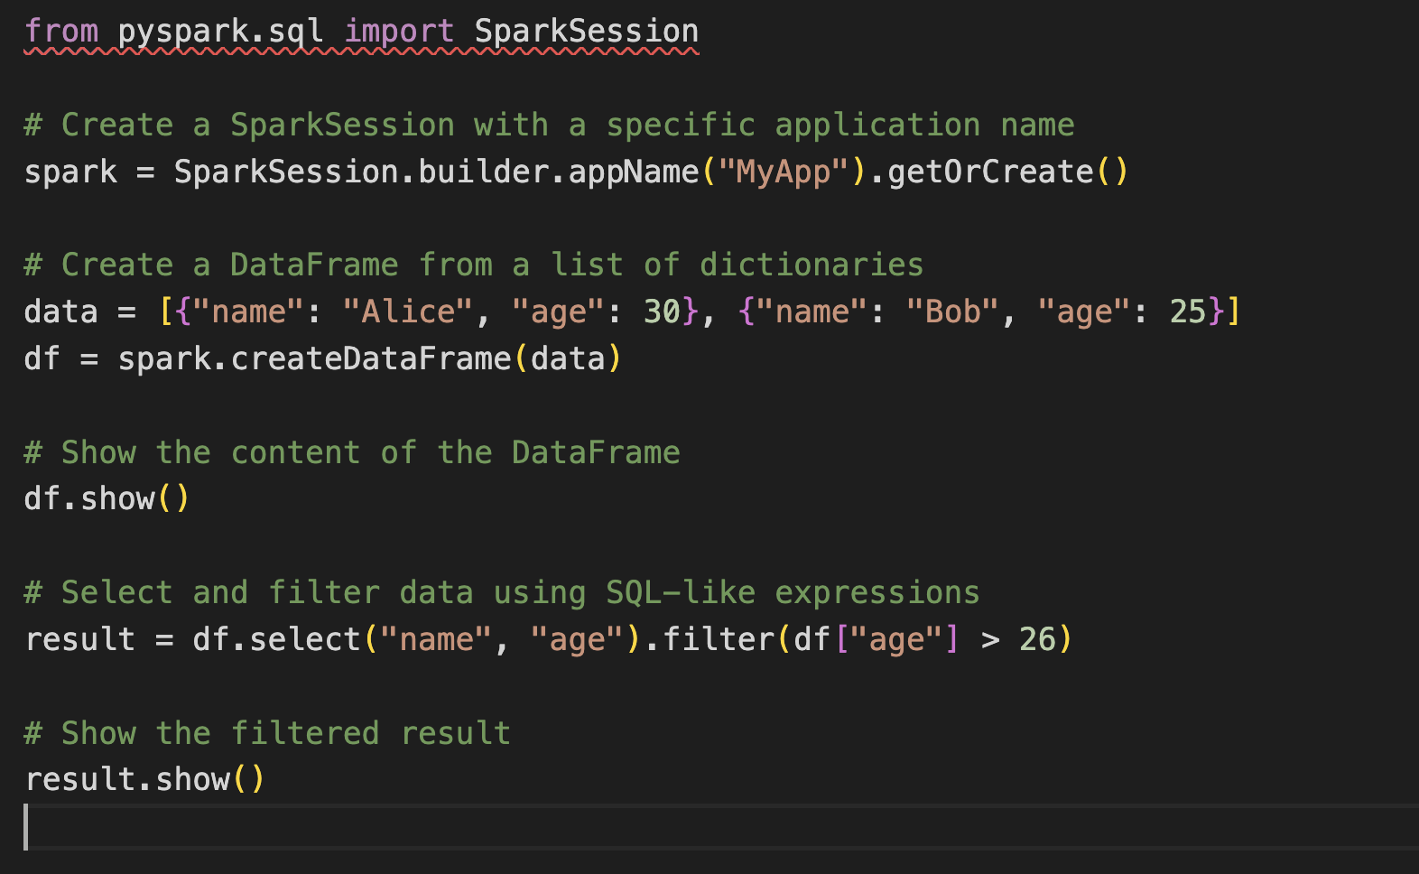

In this example:

1. We import the **SparkSession** class from the **pyspark.sql** module.
2. We create a SparkSession named "MyApp" using **SparkSession.builder.appName("MyApp").getOrCreate()**. The **appName** method sets a name for the Spark application.
3. We create a DataFrame named **df** from a list of dictionaries. This DataFrame represents structured data with two columns: "name" and "age."
4. We use the **show** method to display the content of the DataFrame, showing both the "name" and "age" columns.
5. We perform a selection and filter operation on the DataFrame, similar to using SQL. We select only the "name" and "age" columns where the "age" is greater than 26.
6. We use the **show** method again to display the filtered result.

Creating a RDD

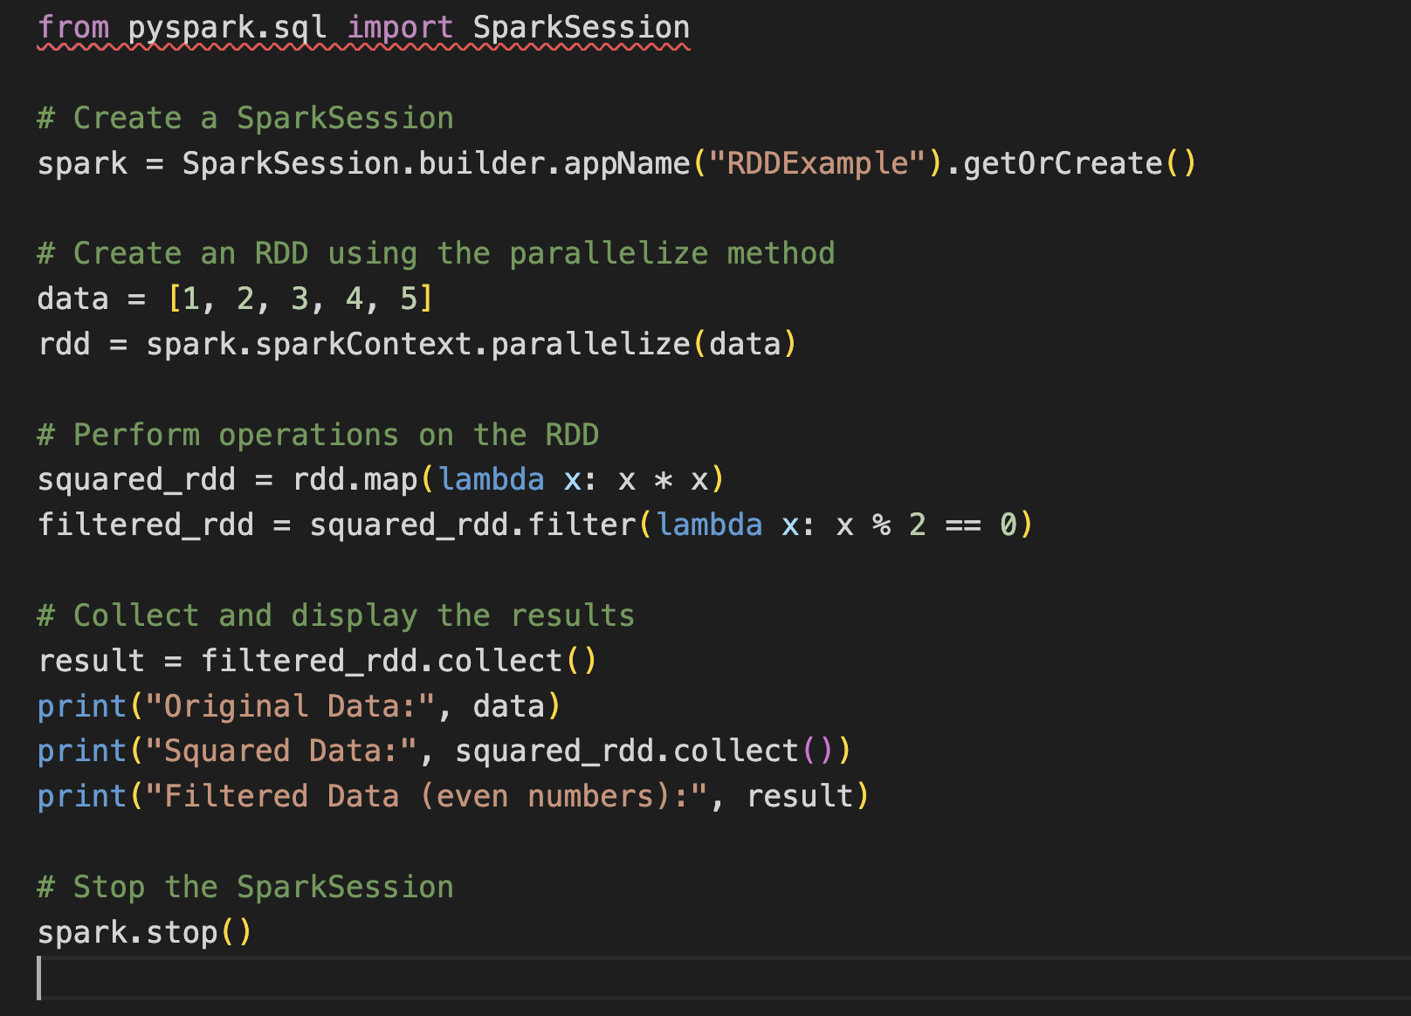

In this example:

1. We create a SparkSession with the name "RDDExample."
2. We create an RDD named **rdd** using the **parallelize** method and provide it with a list of integers (1, 2, 3, 4, 5).
3. We perform transformations on the RDD, such as squaring each element and filtering for even numbers.
4. We collect the results of the transformations using the **collect** method and display the original data, squared data, and the filtered data (even numbers).
5. Finally, we stop the SparkSession to release resources.

These RDD operations and actions are fundamental to Apache Spark's data processing capabilities, allowing users to perform transformations and extract information from large distributed datasets efficiently and in a fault-tolerant manner.

1. **map** Transformation:
   * Description: The **map** transformation applies a given function to each element of the RDD, producing a new RDD with the results of the function applied to each element.
   * Example: In the provided example, **map** is used to square each element in the RDD, creating a new RDD with the squared values.
2. **filter** Transformation:
   * Description: The **filter** transformation filters the elements of an RDD based on a specified condition, creating a new RDD that contains only the elements satisfying the condition.
   * Example: In the example, **filter** is applied to keep only the even numbers from the squared RDD.
3. **reduce** Transformation:
   * Description: The **reduce** transformation aggregates the elements of an RDD by successively applying a binary operation (function) to combine elements two at a time, reducing the RDD to a single value.
   * Example: The **reduce** operation calculates the sum of all elements in the original RDD.
4. **distinct** Transformation:
   * Description: The **distinct** transformation returns a new RDD with distinct (unique) elements from the original RDD.
   * Example: In the provided example, **distinct** is used to obtain a new RDD with unique elements from the original RDD.
5. **collect** Action:
   * Description: The **collect** action retrieves all the elements of an RDD and returns them as a list in the driver program. This action should be used with caution for large RDDs, as it brings all data to the driver.
   * Example: In the example, the **collect** action is used to obtain the results of the **squared_rdd** and **filtered_rdd** transformations as lists.
6. **count** Action:
   * Description: The **count** action returns the total number of elements in the RDD.
   * Example: In the example, the **count** action is used to count the number of even numbers after filtering.
7. **first** Action:
   * Description: The **first** action retrieves the first element from the RDD.
   * Example: In the example, the **first** action is used to retrieve the first element of the original RDD.
8. **take** Action:
   * Description: The **take** action retrieves the first n elements of the RDD as a list. It does not require collecting the entire RDD.
   * Example: In the example, the **take** action is used to obtain the first three elements of the original RDD.

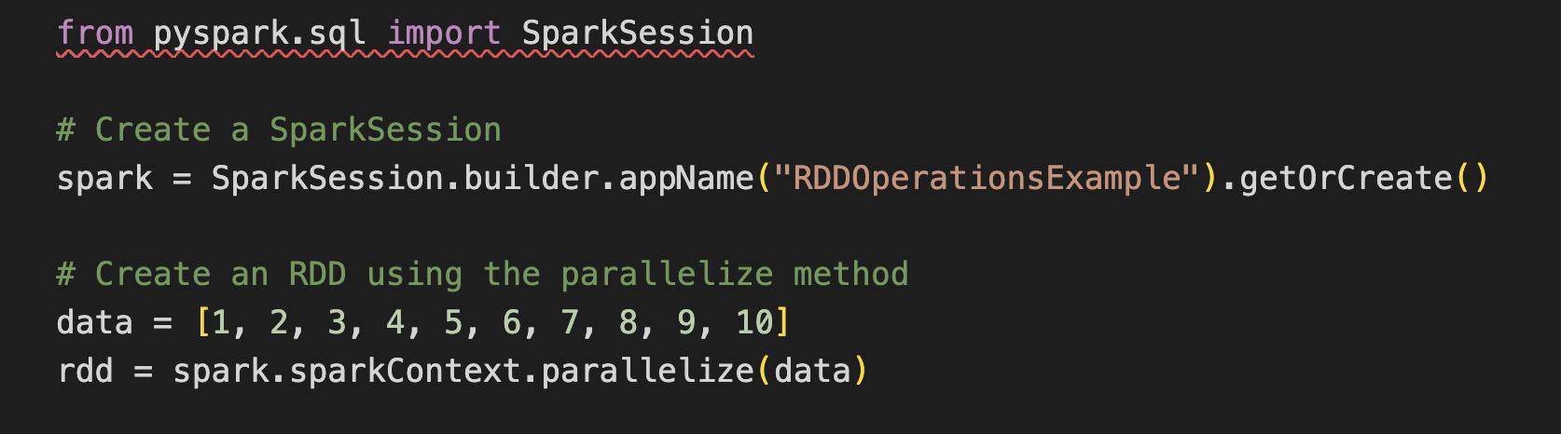

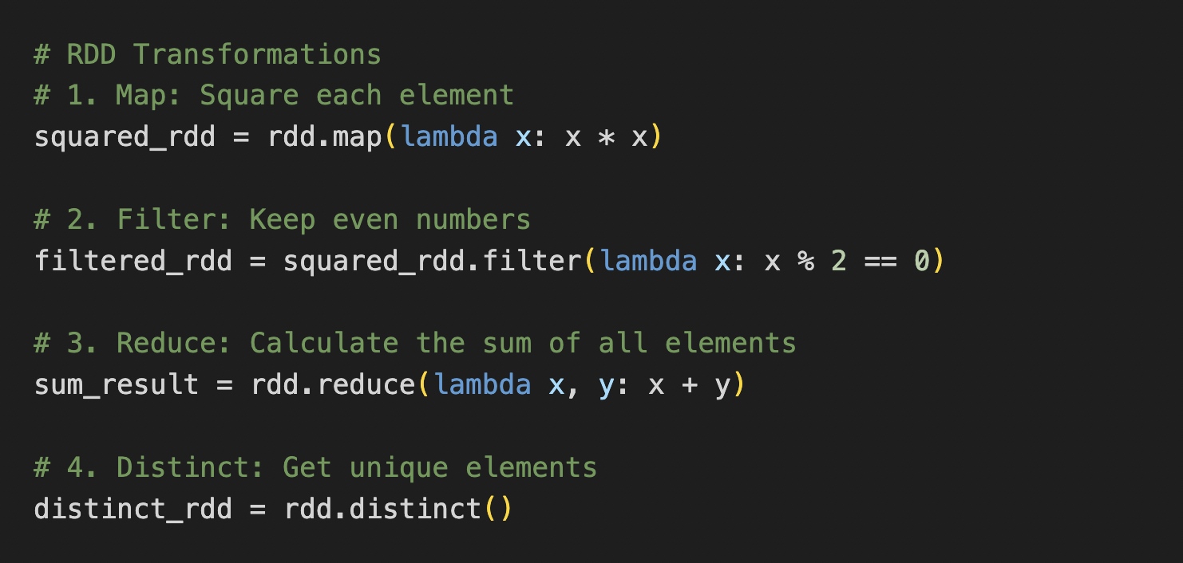

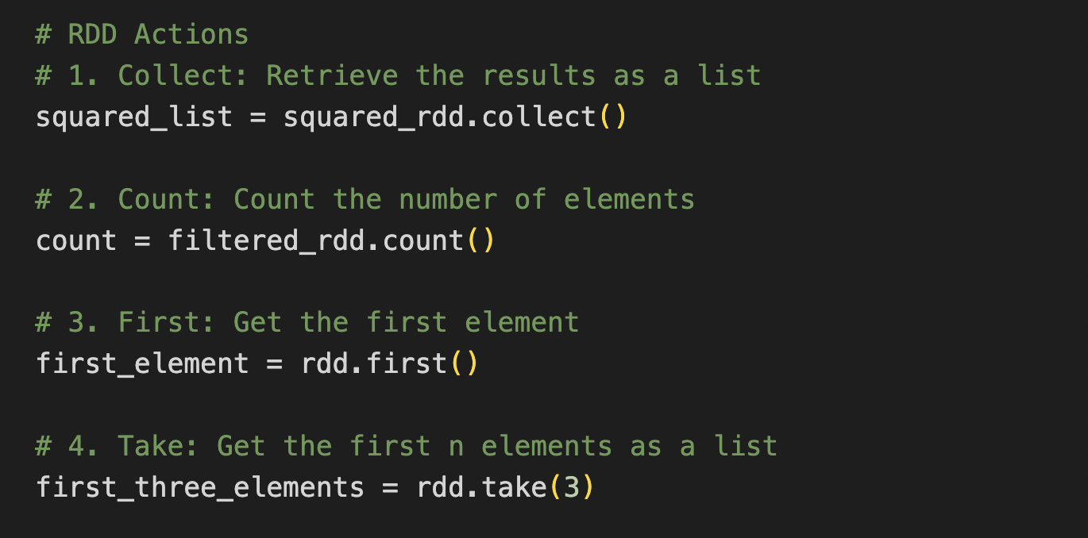

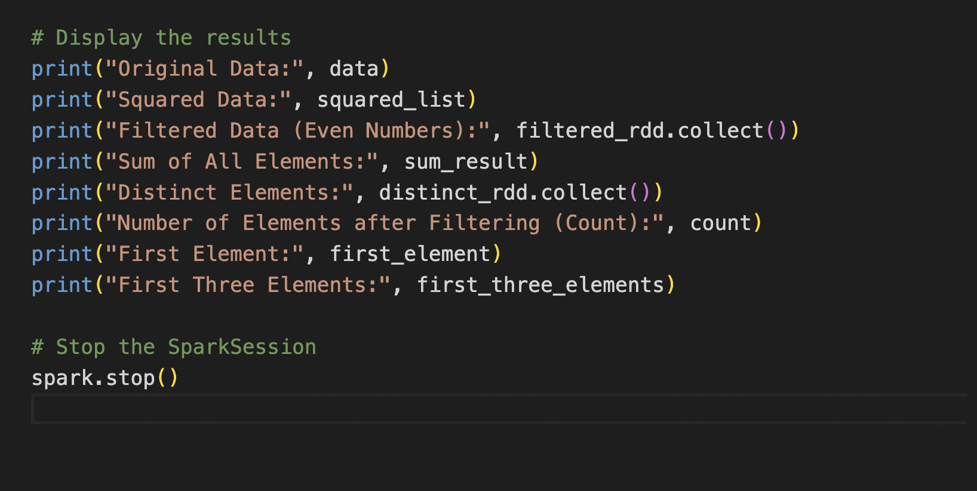

Creating a Data Frame:

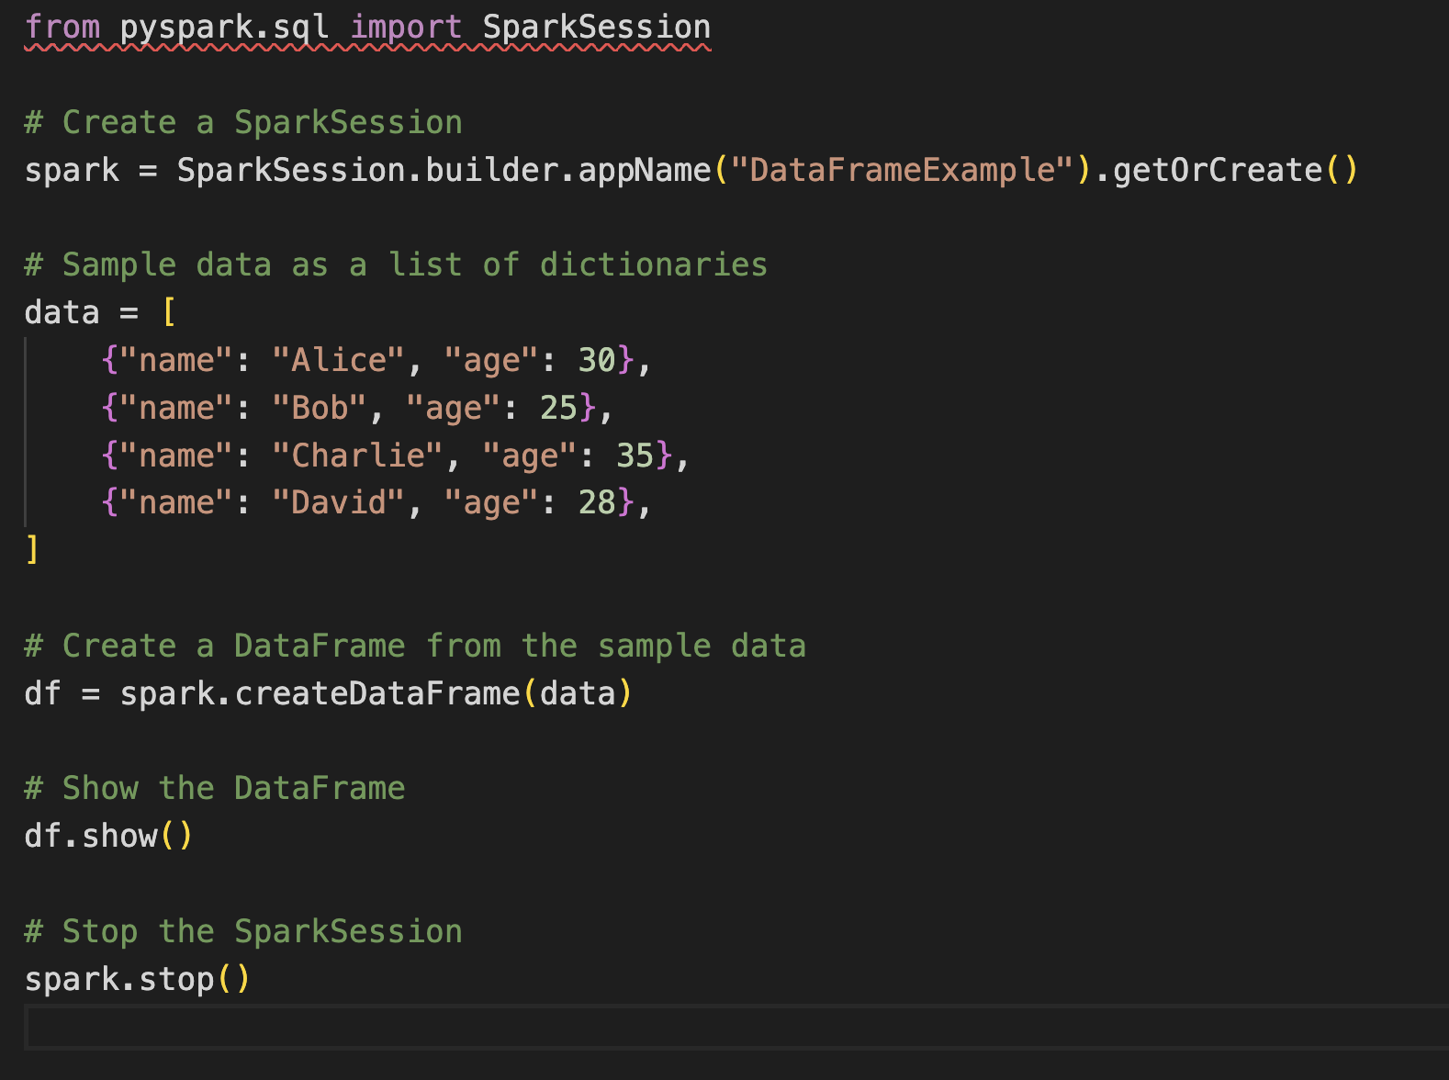

1. We import **SparkSession** to create a Spark session.
2. We create a Spark session named "DataFrameExample" using **SparkSession.builder.appName("DataFrameExample").getOrCreate()**.
3. We define sample data as a list of dictionaries, where each dictionary represents a row in the DataFrame. Each dictionary contains two columns, "name" and "age."
4. We use **spark.createDataFrame(data)** to create a DataFrame named "df" from the sample data.
5. We use **df.show()** to display the contents of the DataFrame.
6. Finally, we stop the Spark session using **spark.stop()** to release resources.

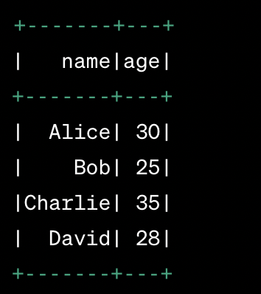

To create a DataFrame from a CSV file in Apache Spark, you can use the read.csv method provided by Spark's SparkSession.

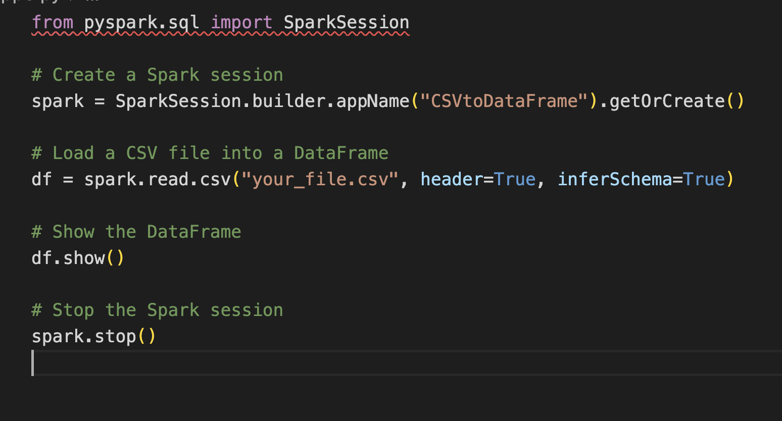

1. We create a Spark session using **SparkSession.builder.appName("CSVtoDataFrame").getOrCreate()**.
2. We use the **spark.read.csv("your_file.csv", header=True, inferSchema=True)** method to read the CSV file. Replace **"your_file.csv"** with the path to your CSV file. The **header=True** option specifies that the first row of the CSV file contains column names, and **inferSchema=True** tries to infer the data types of the columns.
3. We display the contents of the DataFrame using **df.show()**.
4. Finally, we stop the Spark session using **spark.stop()** to release resources.